- ALPHA-BETA PRUNING
AIM
To implement the Alpha-Beta Pruning algorithm in Python for a Tic-Tac-Toe game, where the computer selects the best possible move efficiently.
OBJECTIVE
- To understand the Alpha-Beta Pruning algorithm.
- To implement game-playing using Python.
- To reduce unnecessary searches in the Minimax algorithm.
- To determine the winner or draw.
ALGORITHM
- Start the program.
- Initialize an empty Tic-Tac-Toe board.
- Define all possible winning combinations.
- Accept the player's move manually.
- Check whether the player has won.
- Apply the Alpha-Beta Pruning algorithm to find the computer's best move.
- Update the board with the computer's move.
- Check whether the computer has won.
- Repeat the process until a player wins or the board is full.
- Display the winner or draw.
- Stop the program.

FLOWCHART:
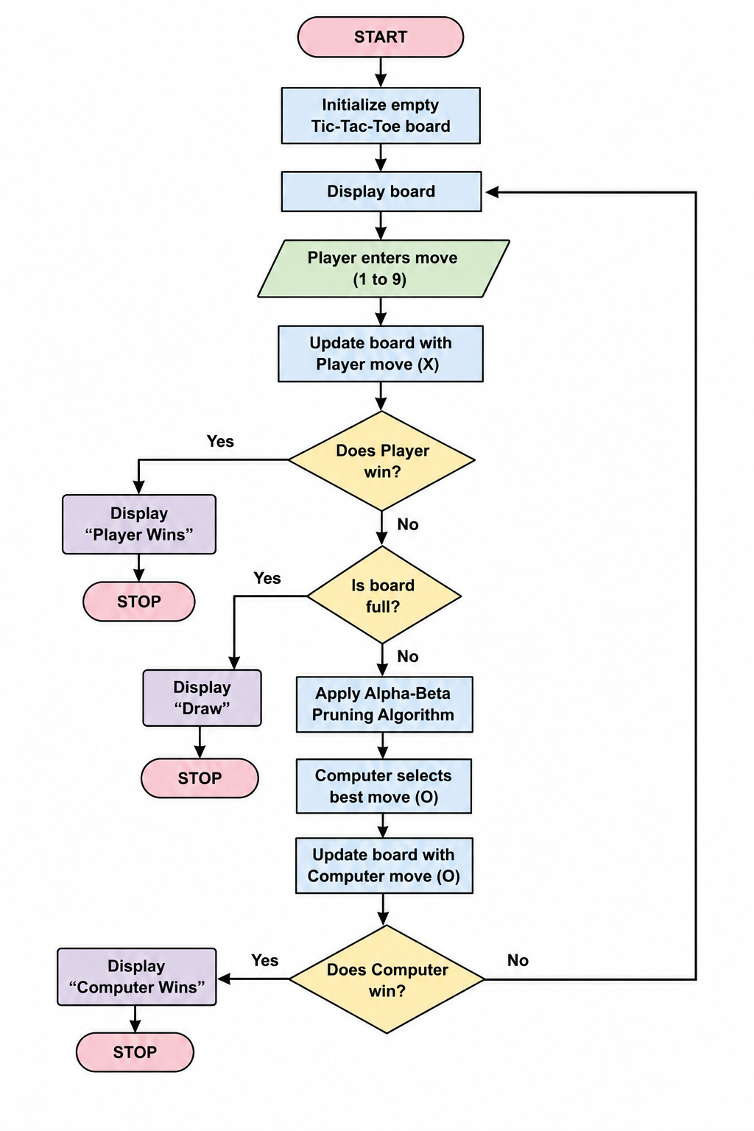
PYTHON CODE:
b=[" "]*9
w=[(0,1,2),(3,4,5),(6,7,8),(0,3,6),(1,4,7),(2,5,8),(0,4,8),(2,4,6)]
def win(p): return any(all(b[i]==p for i in x) for x in w)
def ab(a,be,maxi):
if win("O"): return 1
if win("X"): return -1
if " " not in b: return 0
if maxi:
v=-2
for i in range(9):
if b[i]==" ":
b[i]="O"; v=max(v,ab(a,be,0)); b[i]=" "
a=max(a,v)
if a>=be: break
return v
v=2
for i in range(9):
if b[i]==" ":
b[i]="X"; v=min(v,ab(a,be,1)); b[i]=" "
be=min(be,v)
if a>=be: break
return v
for t in range(9):
print(b[:3],b[3:6],b[6:])
if t%2==0:
p=int(input("Enter position (1-9): "))-1
if b[p]!=" ": continue
b[p]="X"
else:
best=max((ab(-2,2,0),i) for i in range(9) if b[i]==" ")[1]
b[best]="O"
if win("X"): print("You Win!"); break
if win("O"): print("Computer Wins!"); break
else: print("Draw!")
OUTPUT:
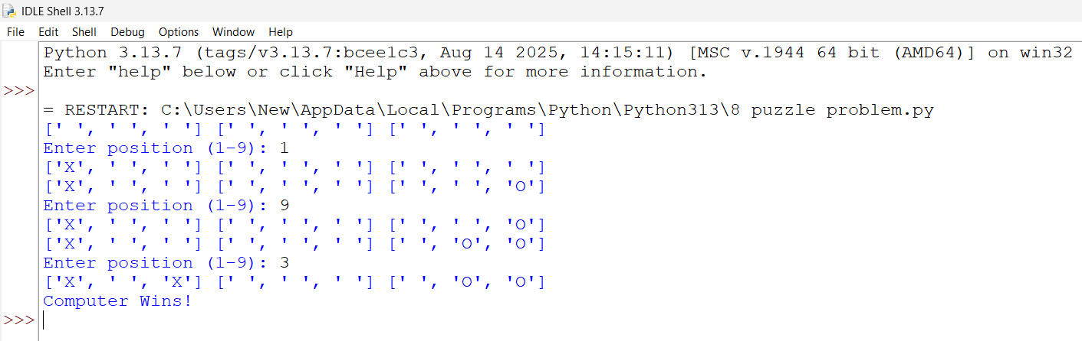
RESULT:
Thus, the Alpha-Beta Pruning algorithm was successfully implemented in Python for Tic-Tac-Toe. The computer efficiently finds the best move by eliminating unnecessary game states and correctly determines the winner or draw.

